**Refer to the ERD for the data types and NOT NULL vs. optional requirement (We should just add everything since we can). We need to be CONSISTENT with our PK’s and FK’s**

INSERT INTO Survey

(Survey_ID, Overall_Score, Quality_Score, Timeliness_Score, Fair_Price_Score, Staff_Friendliness_Score)

VALUES

(1, 9, 10, 8, 9, 9),

(2, 10, 10, 9, 10, 10 ),

(3, 8, 9, 7, 9, 8 ),

(4, 9, 10, 9, 9, 10 ),

(5, 10, 9, 9, 10, 10 ),

(6, 10, 8, 9, 10, 9 ),

(7, 9, 10, 10, 9, 9 ),

(8, 6, 7, 8, 7, 6 ),

(9, 9, 9, 8, 8, 8 ),

(10, 10, 10, 9, 10, 10 )

;

INSERT INTO Payment

(Payment_ID, Method, Date, Total_Cost)

VALUES

(111, 'Cash', '08-03-2022' , $20.00),

(112, 'Debit', '08-05-2022', $25.00),

(113, 'Credit', '08-10-2022', $30.00),

(114, 'Debit', '08-15-2022', $45.00),

(115, 'Debit', '08-25-2022', $40.00),

(116, 'Cash', '08-29-2022', $55.00),

(117, 'Credit', '09-05-2022', $50.00),

(118, 'Credit', '09-15-2022', $65.00),

(119, 'Debit', '09-25-2022', $60.00),

(120, 'Cash', '10-10-2022', $70.00)

INSERT INTO Cost

(Service_Cost_ID, Service_Name, Cost_per_Unit, Service_Description)

VALUES

(001, 'Basic Service', $20.00, 'S - Bath, Blow Dry, and Brush'),

(002, 'Basic Service', $30.00, 'S - Bath, Blow Dry, and Brush'),

(003, 'Basic Service', $40.00, 'S - Bath, Blow Dry, and Brush'),

(004, 'Basic Service', $50.00, 'S - Bath, Blow Dry, and Brush'),

(005, 'Basic Service', $60.00, 'S - Bath, Blow Dry, and Brush'),

(006, 'Basic Service', $25.00, 'L - Bath, Blow Dry, and Brush'),

(007, 'Basic Service', $45.00, 'L - Bath, Blow Dry, and Brush'),

(008, 'Basic Service', $55.00, 'L - Bath, Blow Dry, and Brush'),

(009, 'Basic Service', $65.00, 'L - Bath, Blow Dry, and Brush'),

(010, 'Basic Service', $70.00, 'L - Bath, Blow Dry, and Brush'),

(011, 'Specialty Service ', $8.00, 'Nail Trim'),

(012, 'Specialty Service ', $5.00, 'Ear Cleaning'),

(013, 'Specialty Service ', $25.00, 'Skin Scrape'),

(014, 'Specialty Service ', $10.00, 'Ear Mite Treatment'),

(015, 'Specialty Service ', $15.00, 'Flea Treatment'),

(016, 'Specialty Service ', $12.50, 'Tick Treatment'),

(017, 'Specialty Service ', $8.50, 'Teeth Brushing'),

(018, 'Specialty Service ', $6.00, 'Nose & Pad Conditioning'),

(019, 'Specialty Service ', $7.50, 'Eye Cleaning & Drops'),

(020, 'Specialty Service ', $15.00, 'Hair Cut'),

(021, 'Specialty Service ', $4.00, 'Chalking (5 colors available)'),

(022, 'Specialty Service ', $7.00, 'Stenciling (20 designs, 8 colors)'),

(023, 'Specialty Service ', $5.00, 'Feathering (6 options'),

(024, 'Specialty Service ', $15.00, 'Vitamins (soft shiny coat'),

(025, 'Specialty Service ', $30.00, 'Matted Hair')

;

INSERT INTO Pet_Client

(Pet_Client_ID, Pet_Owner_ID, Pet_Name, Species, Breed, Primary_Color, Secondary_Color, Weight, Hair_Length, Age, Birthdate, Gender, Date_Last_Seen, Number_of_Visits, Number_of_Services_Performed)

VALUES

(1, 101, 'Bella', 'Cat', 'Siamese Cat', 'Brown', 'White', 20 ,'L', 8, '2/10/2014', 'F', '9/22/2022', 2, 5)

(2, 102, 'Luna', 'dog', 'pug', 'White', 'N/A',0, 'S', 3, '3-11-2019', 'F', '04-27-2022', 4, 4),

(3, 103, 'Lucy', 'dog', 'pug', 'White', 'N/A', 40, 'S', 6, '3-11-2016' , 'F' , '01-28-2022', 1, 3),

(4, 104, 'Daisy', 'cat', 'siamese cat', 'Brown', 'Gray', 55, 'L', 6, '2-10-2016', 'M', '05-24-2021', 1, 2),

(5, 105, 'Lola', 'dog', 'pug', 'White', 'Black', 60, 'S', 9, '2-10-2013', 'F', '06-09-2021', 5, 7),

(6, 106, 'Sadie', 'cat', 'siamese cat', 'Black', 'N/A', 15, 'S', 11, '4-9-2011', 'F', '08-27-2021', 3, 4),

(7, 107, 'Molly', 'dog', 'pug', 'White', 'N/A', 30, 'L', 4, '4-10-2018', 'M', '09-2-2021' , 5, 7),

(8, 108, 'Bailey', 'dog', 'pug', 'Brown', 'N/A', 25, 'L', 2, '2-10-2020', 'F', '05-21-2021', 7, 7),

(9, 109, 'Stella', 'dog', 'pug', 'Brown', 'N/A', 70, 'S', 3, '2-11-2019', 'M', '06-08-2022' , 1, 2),

(10, 110,'Maggie', 'dog', 'pug', 'Black', 'Brown', '82', 'S', 5, '6-10-2017', 'M', '05-04-2022', 3, 3)

;

INSERT INTO Employee

(Employee_ID, SSN, First_Name, Last_Name, Start_Date, Address, Degree_Name, Grad_Date, Years_of_Experience, School_Name, Certificate_Date, Sick_Days_Accrued, Vacation_Days_Accrued, Paycheck_ID)

VALUES

(50935, 284274009, 'Izzy', 'Garcia', '01-01-2020', '156 Broadway', null, null, 2, null, null, 2, 18, 36213),

(10506, 423174174, 'Jamie', 'Smith', '01-01-2020', '897 43rd St', null, null, 2, null, null, 10, 17, 61085),

(44274, 247172055, 'Jacob', 'Lopez', '05-06-2020', '155 Hobart', 'Business', '06-15-2018', 1, 'Sonoma', null, 11, 14, 46883),

(47281, 875389498, 'Jayden', 'Hernandez', '06-07-2020', '574 Grendal', 'Business', '05-12-2017', 2, 'Irvine', null, 10, 12, 30925),

(88087, 638231155, 'Daniel', 'Martinez', '07-06-2021', '875 Rose', null, null, 1, 'Riverside', '06-13-2016', 4, 14, 23358),

(39862, 620757521, 'Emma', 'Rodriguez', '10-06-2021', '315 Willow', null, null, 2, 'Davis', '05-14-2018', 2, 5, 69914),

(77855, 598498666, 'Ethan', 'Johnson', '09-01-2020', '301 Grove', null, null, 1, 'Sacramento', '06-15-2016', 3, 20, 47802),

(62618, 131456195, 'Emily', 'Lee', '12-06-2021', '385 Thacher', null, null, 2, 'Chico', '05-14-2018', 12, 15, 73426),

(51855, 581545591, 'Matthew', 'Gonzalez', '04-07-2020', '511 Harrison', null, null, 1, 'Merced', '05-14-2018', 2, 12, 81919),

(26042, 371143587, 'Mia', 'Nguyen', '03-25-2021','102 Ocean', null, null, 2, 'Hayward', '05-15-2016', 5, 21, 23873),

(26679, 656809632, 'Noah', 'Williams', '06-30-2020', '258 Lincoln', null, null, 1, 'Berkeley', '06-15-2017', 11, 27, null),

(67525, 583737103, 'Olivia', 'Perez', '09-20-2020', '294 Miller', null, null, 2, 'San Marcos', '05-14-2018', 6, 10, null),

(87637, 873429702, 'Anthony', 'Ramirez', '01-22-2020', '134 First', null, null, 1, 'San Diego', '05-15-2016', 6, 30, null),

(12348, 167236943, 'Sofia', 'Sanchez', '08-08-2021', '416 Lima', null, null, 2, 'Santa Barbara', '06-15-2017', 2, 7, null)

;

INSERT INTO Pet_Client_Medical_Record

(Medical_Record_ID, Pet_Client_ID, Rabies_Vacc_Status, Spayed_or_Neutured)

VALUES

(101, 1, 'Y', 'S')

(102,2,'Y','S'),

(103,3,'Y','S'),

(104,4,'N','N'),

(105,5,'Y','S'),

(106,6,'N','S'),

(107,7,'N','S'),

(108,8,'Y','S'),

(109,10,'Y','N'),

(110,10,'Y','N')

;

INSERT INTO Pet_Owner

(Pet_Owner_ID, First_Name, Middle_Initial, Last_Name, Email, Phone, Date_Last_Seen, Number_of_Visits, Pet_Client_ID)

Values

(101, 'Alisha', 'H', 'Welton', 'awelton@outlook.com', '(816) 597-3654','09-07-2021', 2, 1,),

(102, 'Hamza', '', 'Walsh', 'hwalsh@outlook.com','(625) 555-0511', '04-27-2021', 4, 2),

(103, 'Danika','B','Soto','dsoto@yahoo.ca', '(380) 295-6543', '01-28-2022', 1, 3),

(104, 'Callie','','Colon','ccolon@gmail.com','(767) 484-3604','05-24-2021', 1, 4),

(105, 'Hamza','','Mercado','hmercado@aol.ca','(902) 286-9970','06-09-2021', 5 ,5),

(106, 'Finnegan','','Jackson','fjackson@gmail.com','(302) 580-1523','08-27-2021',3,6),

(107, 'Humberto','','Phillips','hphilips@gmail.ca','(233) 240-1165','09-02-2021', 5, 7),

(108, 'Damian','','Ballard','dballard@aol.ca','(767) 484-3603','05-21-2021', 7, 8),

(109, 'Oliver','P','Rangel', 'orangel@ccglobal.ca','(626) 588-8314','06-08-2022',1,9),

(110, 'Dorian','','Berg',' dberg@yahoo.ca','(767) 484-3605','05-06-2022', 3, 10)

INSERT INTO Employee_Payment

(Paycheck_ID, Statement_ID, Pay_Period_Start_Date, Pay_Period_End_Date, Date_Issued, Employee_Type, Bank_Name, Account_ID,

Direct_Deposit, Hourly_Rate, Hours_Worked, Statement_Total_Amount, Medical_Deduction, Dental_Deduction, Disability_Deduction, Life_Insurance_Deduction, Statement_Net_Amount)

VALUES

(36213, 40959, '06-10-2022', '06-24-2022', '07-01-2022', 'O', 'Chase', 48031, 'Y', 35, 21 , $735, 40, 10, 15, 15, $655),

(61085, 12342, '06-10-2022', '06-24-2022', '07-01-2022', 'O', 'Citi', 42479, 'Y', 35, 23, $805, 40, 10, 15, 15, $725),

(46883, 62606, '06-10-2022', '06-24-2022', '07-01-2022', 'F', 'Chase', 85834, 'Y', 23, 31, $713, 40, 10, 15, 15, $633),

(30925, 45881, '06-10-2022', '06-24-2022', '07-01-2022', 'F', 'Citi', 79536, 'Y', 23, 32, $736, 40, 10, 15, 15, $656),

(23358, 64731, '06-10-2022', '06-24-2022', '07-01-2022', 'F', 'Chase', 76122, 'Y', 18, 25, $450, 40, 10, 15, 15, $370),

(69914, 29699, '06-10-2022', '06-24-2022', '07-01-2022', 'F', 'Citi', 82926, 'Y', 26, 21, $546, 40, 10, 15, 15, $466),

(47802, 46722, '06-10-2022', '06-24-2022', '07-01-2022', 'F', 'Chase', 46195, 'Y', 27, 21, $567, 40, 10, 15, 15, $487),

(73426, 23852, '06-10-2022', '06-24-2022', '07-01-2022', 'F', 'Chase', 46195, 'Y', 28, 22, $616, 40, 10, 15, 15, $536),

(81919, 46740, '06-10-2022', '06-24-2022', '07-01-2022', 'F', 'Chase', 18594, 'Y', 29, 35, $735, 40, 10, 15, 15, $655),

(23873, 64549, '06-10-2022', '06-24-2022', '07-01-2022', 'F', 'Citi', 22082, 'Y', 27, 22, $594, 40, 10, 15, 15, $514)

These are the last 4

(58800, 80123, '06-10-2022', '06-24-2022', '07-01-2022', 'F', 'Chase', 12104, 'Y', 21, 25, $441, 40, 10, 15, 15, $361,),

(71837, 76521, '06-10-2022', '06-24-2022', '07-01-2022', 'F', 'Chase', 67819, 'Y', 26, 22, $445, 40, 10, 15, 15, $365,),

(33196, 43866, '06-10-2022', '06-24-2022', '07-01-2022', 'P', 'Citi', 42637, 'Y', 27, 10, $270, 0, 0, 0, 0, $270,),

(35933, 70430, '06-10-2022', '06-24-2022', '07-01-2022', 'P', 'Chase', 39378, 'Y', 27, 12, $324, 0, 0, 0, 0, $324,),

;

INSERT INTO [Service]

(Service_ID, Service_Cost_ID, Quantity, Sale_ID)

VALUES

(4001,001,2,201),

(4002,002,4,202),

(4003,003,1,203),

(4004,004,3,204),

(4005,005,1,205),

(4006,006,2,206),

(4007,007,1,207),

(4008,008,3,208),

(4009,009,1,209),

(4010,010,2,210)

INSERT INTO Sale

INSERT INTO Sale

(Sale_ID, Pet_Client_ID, Service_ID, Payment_ID, Employee_ID, Survey_ID)

VALUES

(201, 1, 4001, 111, 50935, 1),

(202, 2, 4002, 112, 10506, 2),

(203, 3, 4003, 113, 44274, 3),

(204, 4, 4004, 114, 47281, 4),

(205, 5, 4005, 115, 88087, 5),

(206, 6, 4006, 116, 39862, 6),

(207, 7, 4007, 117, 77855, 7),

(208, 8, 4008, 118, 62618, 8),

(209, 9, 4009, 119, 51855, 9),

(210, 10, 4010, 120, 26042, 10)

;

*Last move: removed

1)

Select * 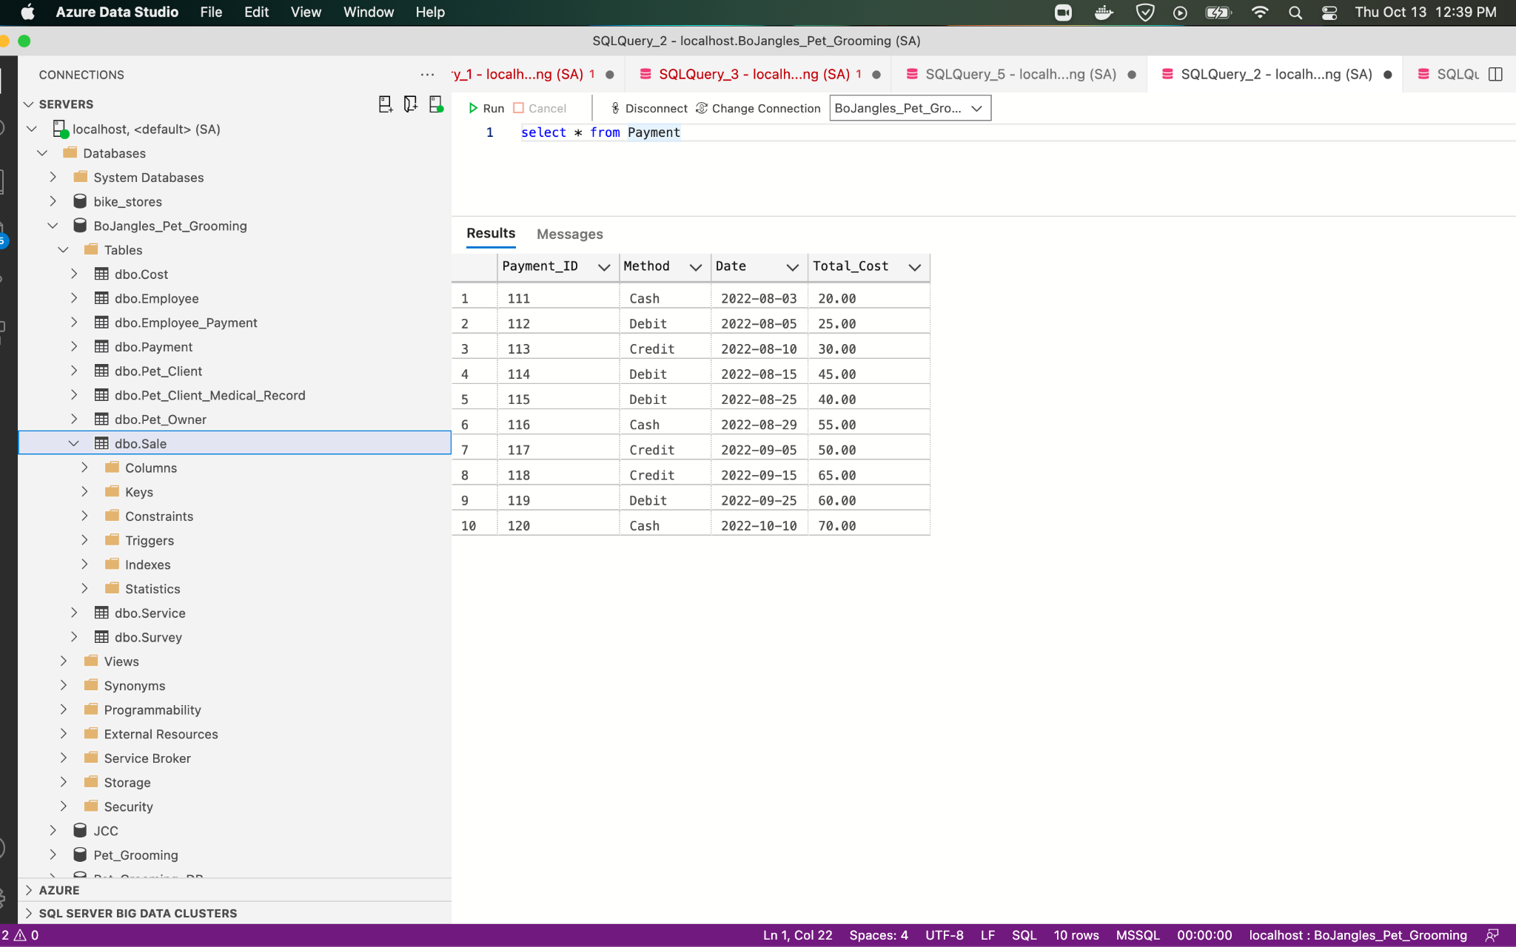

2)

/*Q1 22 REVENUE */

SELECT SUM (TOTAL_COST)

FROM PAYMENT

WHERE DATE BETWEEN 01/01/2022 AND 3/31/2022

3)

/*Q4 21 REVENUE */

SELECT SUM (TOTAL_COST)

FROM PAYMENT

WHERE DATE BETWEEN 10/01/2021 AND 12/31/2021

4)

Screenshot of standalone table (Select *) with all assets and costs (and totals)

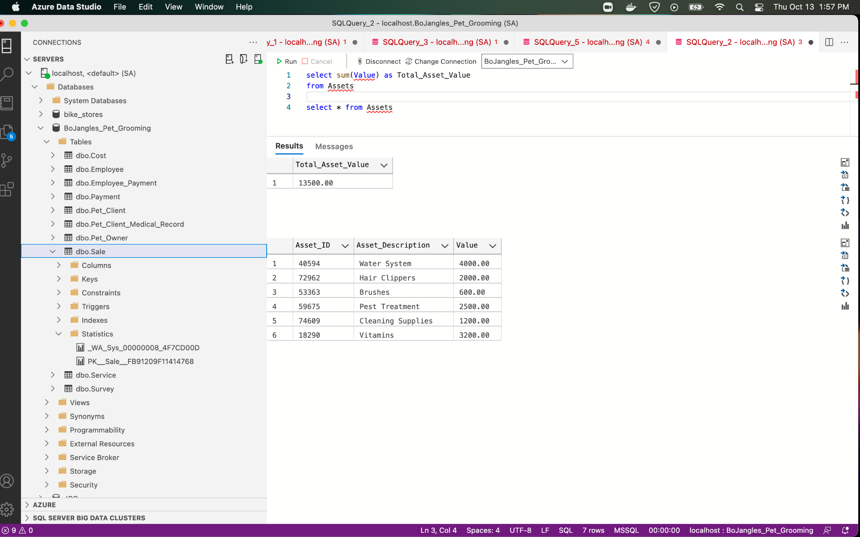

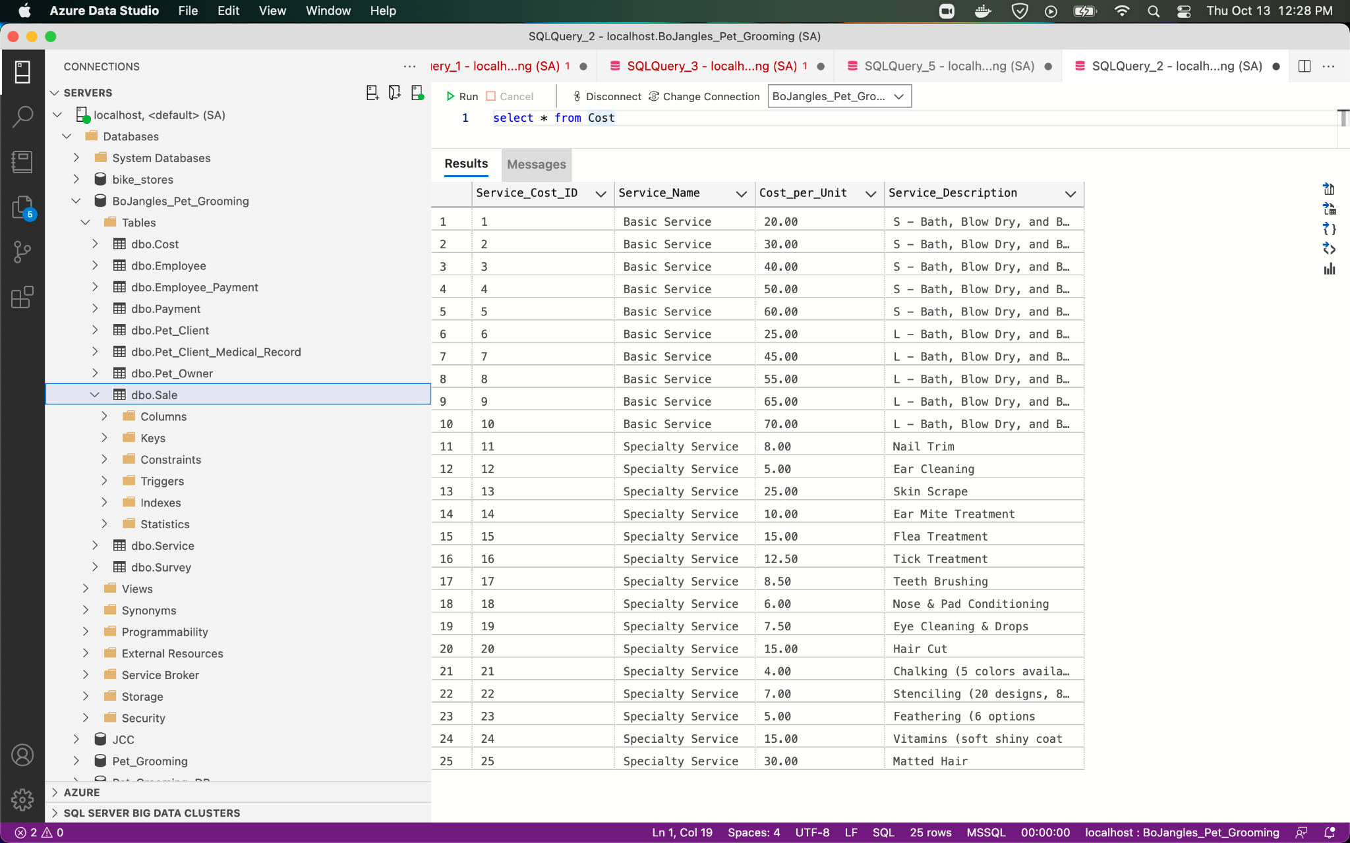

5)

Screenshot of table (Select *) with all Customer Satisfaction scores (and totals)

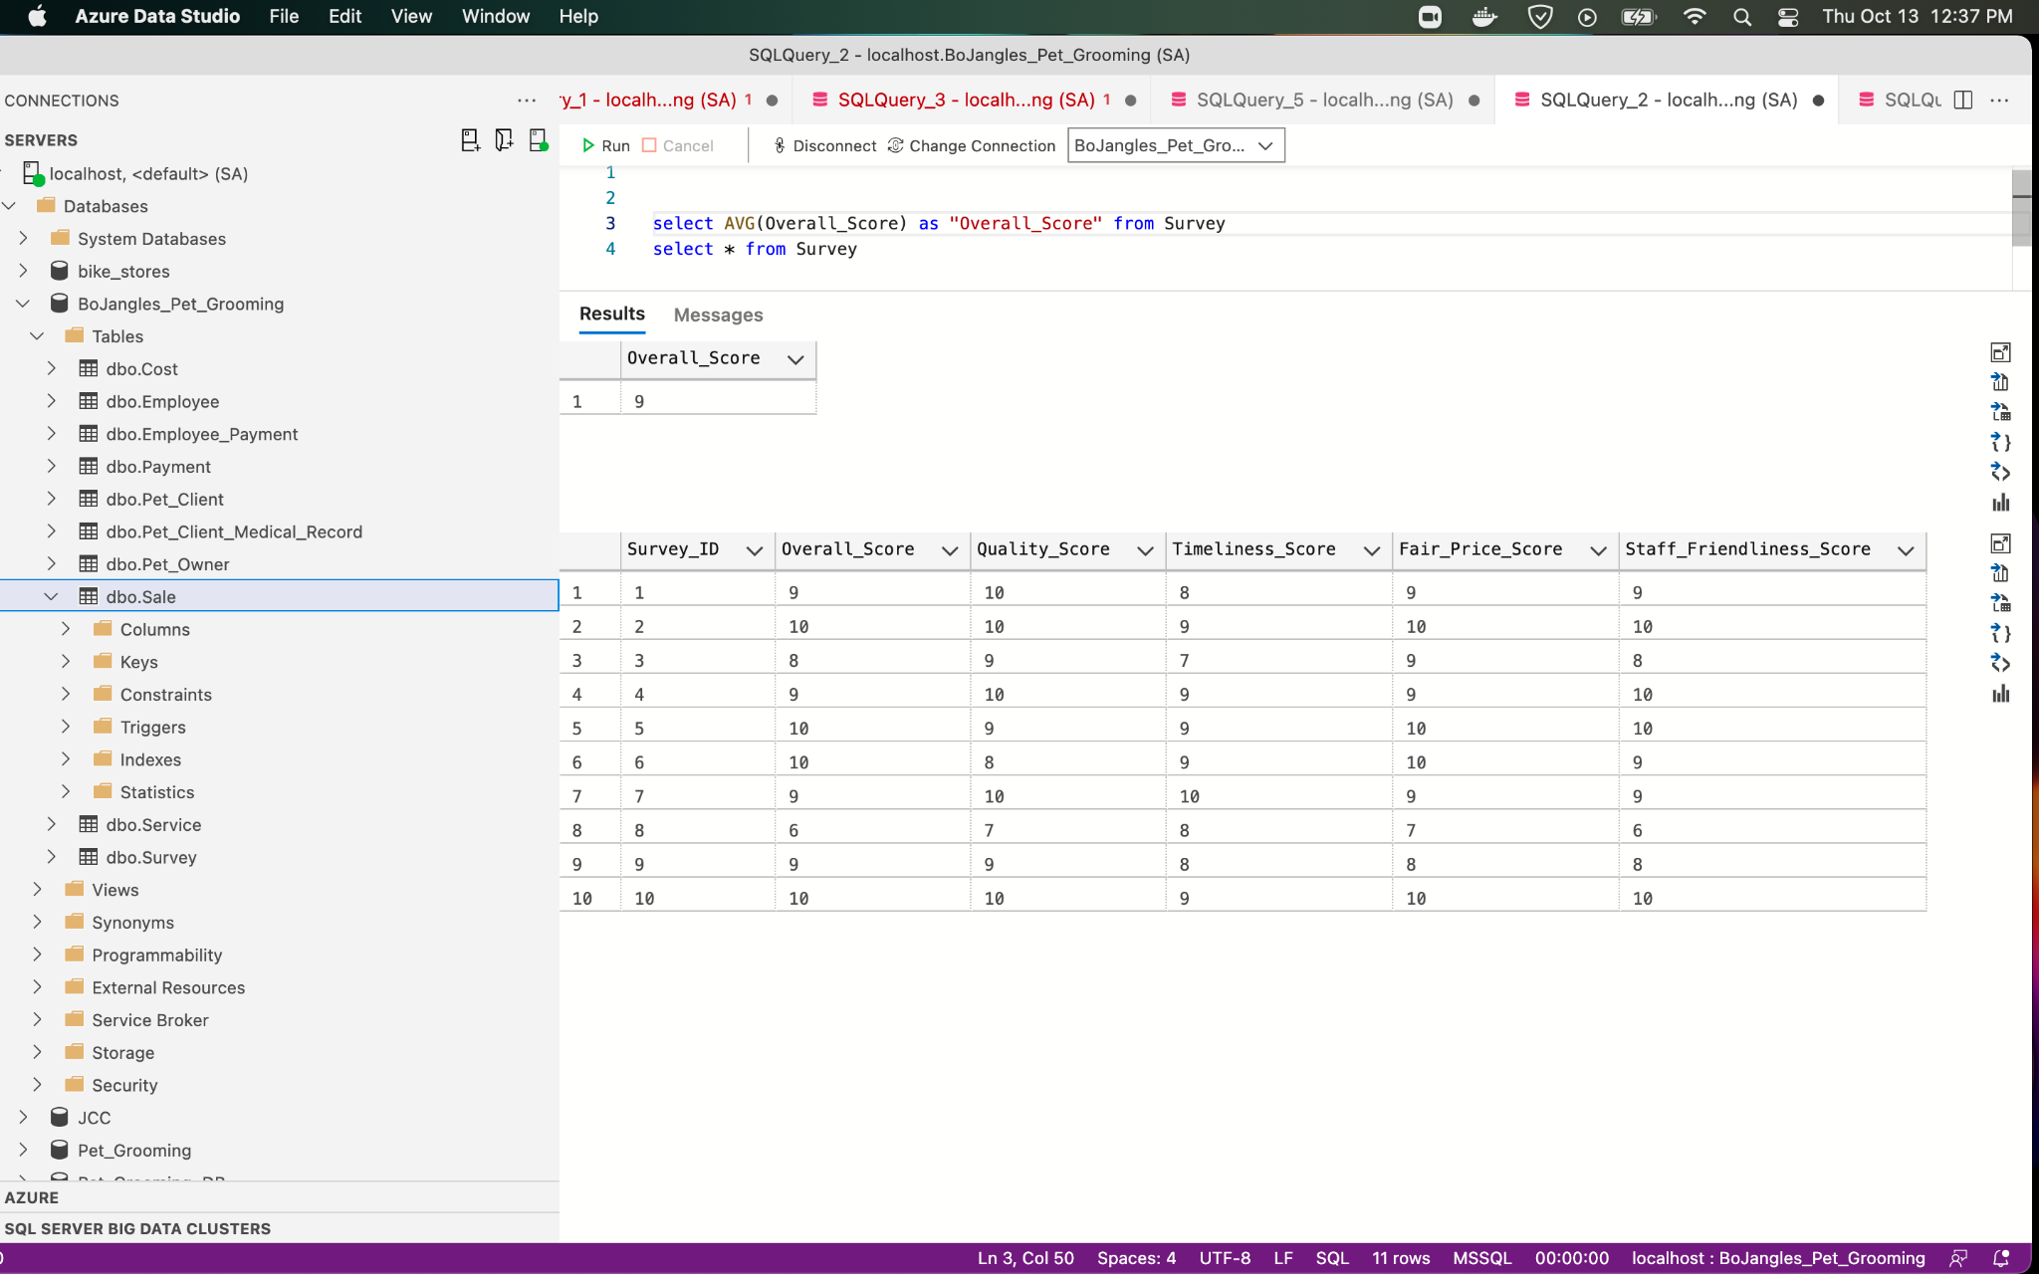

6)

Names of groomers and their clients, and number of times each client was groomed.

SELECT Pet_Owner.First_Name, Pet_Owner.Last_Name, Pet_Client.Pet_Name, Pet_Client.Number_of_Services_Performed

FROM Pet_Owner

Inner join Pet_Client

On Pet_Owner.Pet_Owner_ID = Pet_Client.Pet_Owner_ID

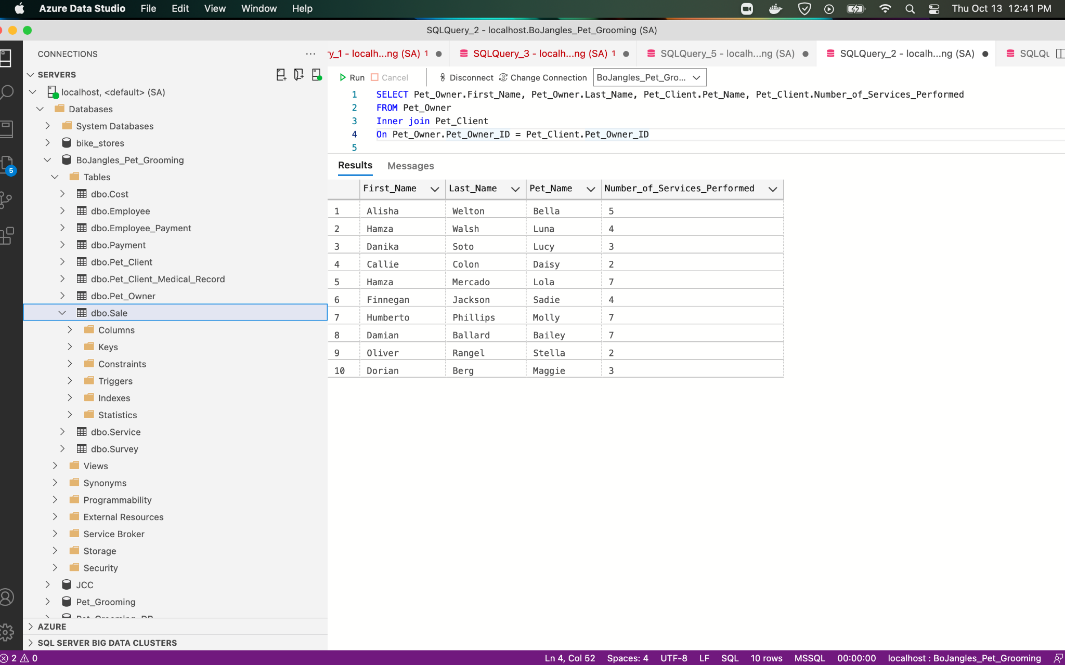

7)

Names of clients not seen in the last year and date last seen.

SELECT Pet_Name, Date_Last_Seen

FROM Pet_Client

WHERE Date_Last_Seen < 01-01-2022

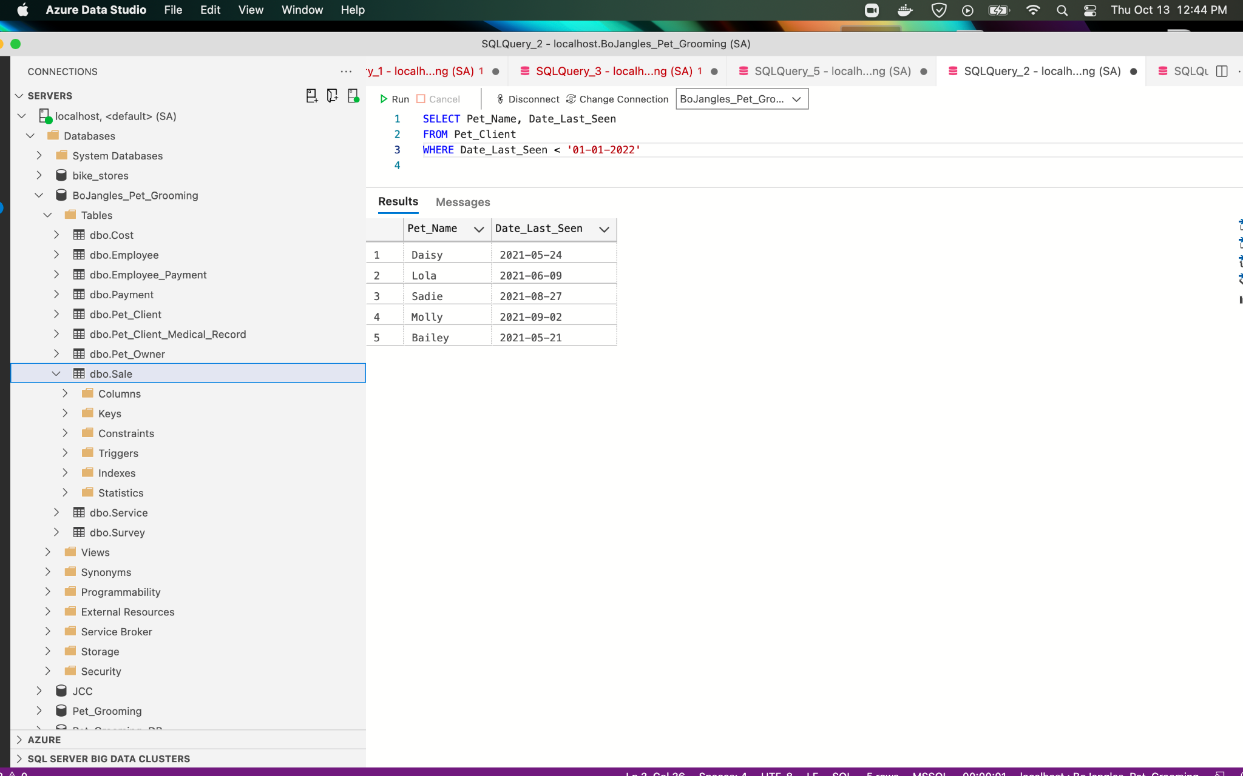

8)

Services performed on animals most often (by species).

SELECT Species , Service_name , Quantity

FROM Pet_Client pc, Cost c, Service s, Sale sl

WHERE sl.Pet_Client_ID = pc.Pet_Client_ID

AND sl.Service_ID = s.Service_ID

ORDER BY Quantity DESC

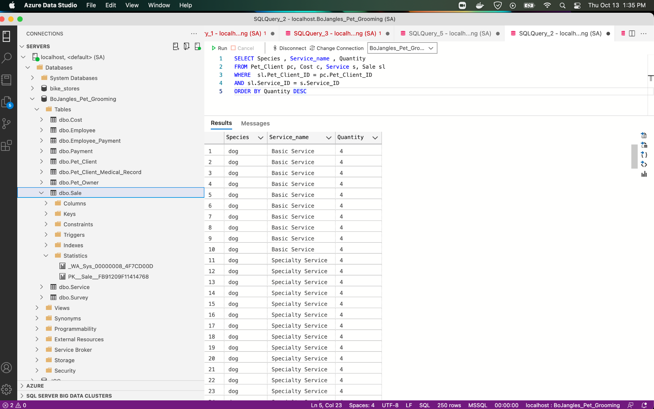

**Which client has had the same walk-in service performed more than once?

- Do we have any fields that captures weather a service was walk-in or appointment

9)

A listing of owners, clients in decreasing order by number of grooming visits.

SELECT Pet_Owner.First_Name, Pet_Owner.Last_Name, Pet_Client.Pet_Name, Pet_Client.Number_of_Vists

FROM Pet_Owner

Inner Join Pet_Client

On Pet_Owner_ID = Pet_Client_ID

ORDER BY Pet_Client.Number_of_Visits DESC;

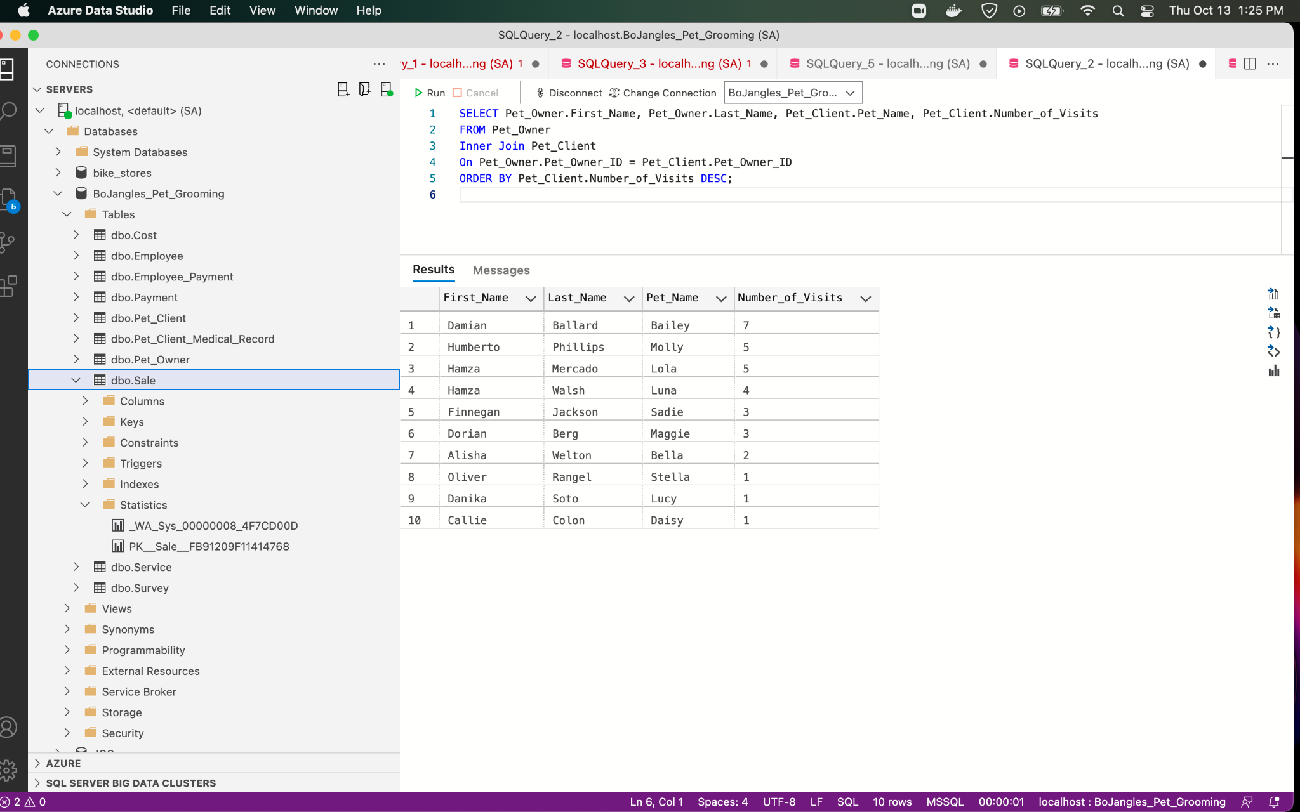

10)

Client that has been groomed the most often

SELECT Pet_Name, Number_of_Services_Performed

FROM Pet_Client

ORDER BY Number_of_Services_Performed DESC

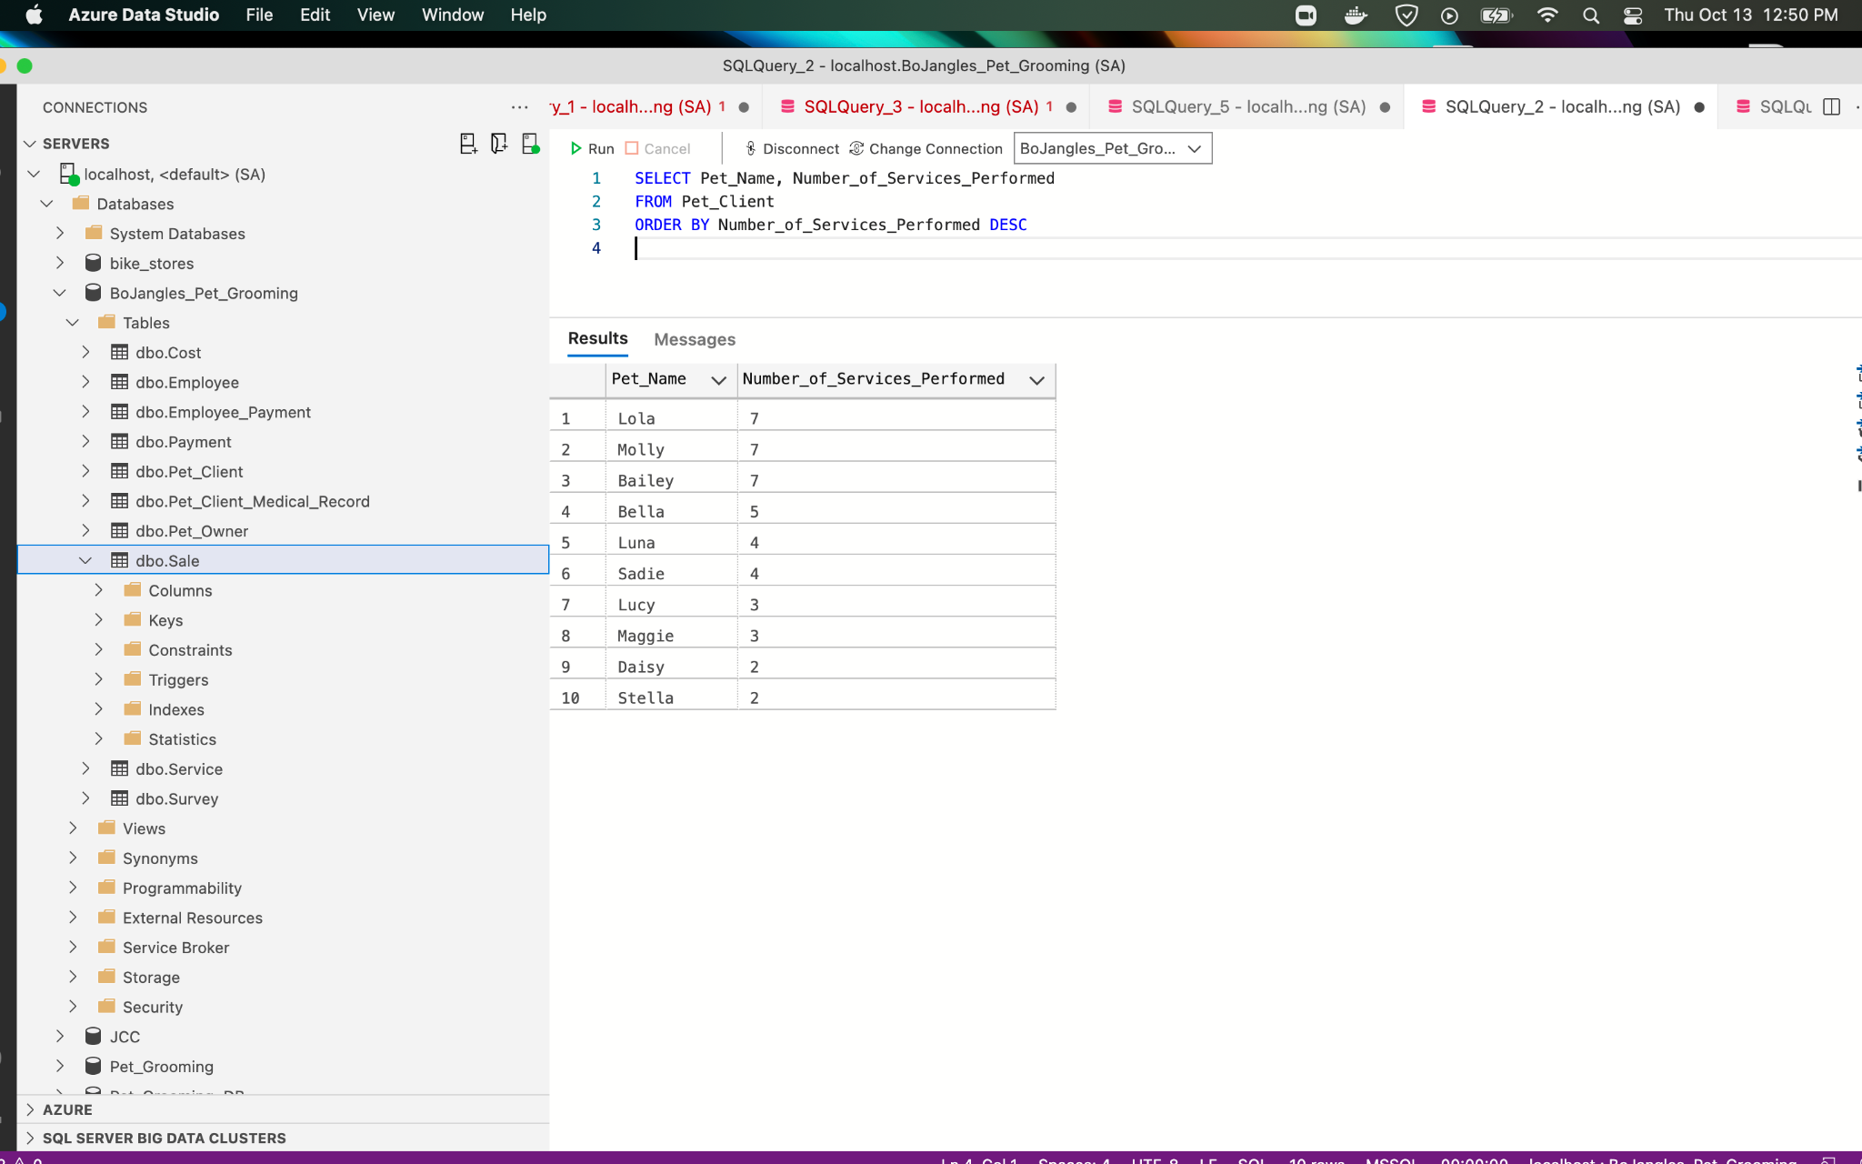

11)

Which employees earn more than the average salary for all employees?

SELECT First_Name, Last_Name, AVG(Statement_Total_Amount) AS Average_Salary

FROM Employee, Employee_Payment

WHERE Employee_ID = Paycheck_ID

AND Statement_Total_Amount >= Average_Salary

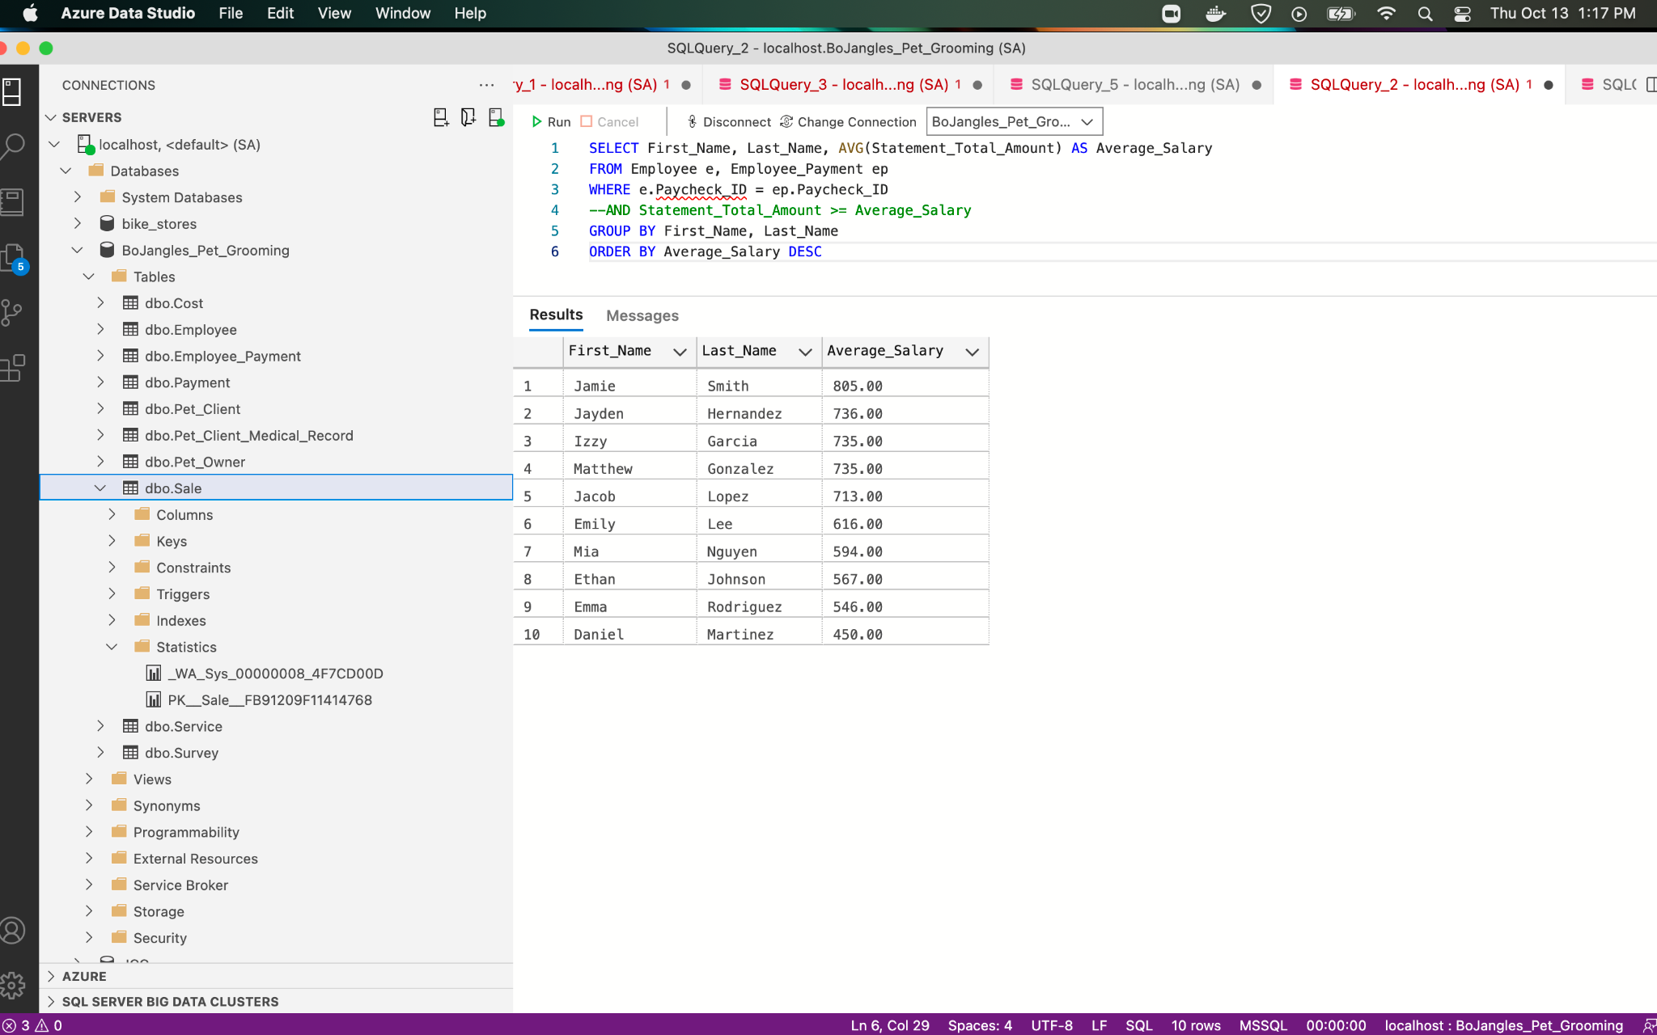

12)

Which part-time employee has been with Mr. Bo Jangles the longest?

SELECT First_Name, Last_Name, Employee_Type, MIN(Start_Date) AS Longest_Stay

FROM Employee as e, Employee_Payment as ep

WHERE e.Paycheck_ID = ep.Paycheck_ID

Group by First_Name, Last_Name, Employee_Type

Order by Longest_Stay

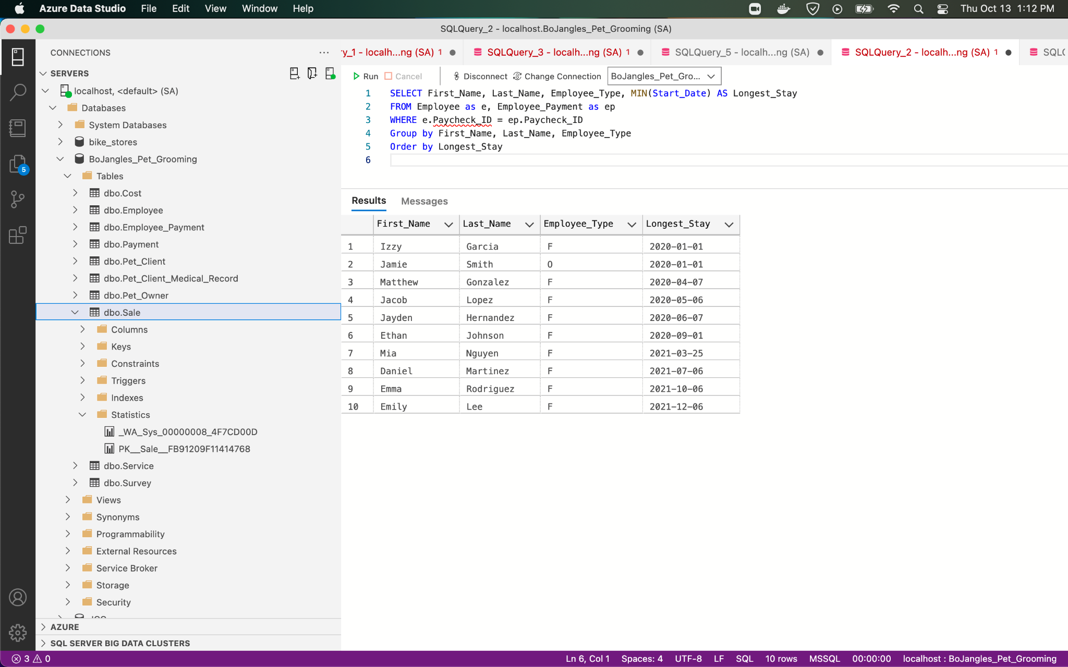

13)

Which employee has the most sick days?

SELECT First_Name, Last_Name, Max(Sick_Days_Accrued) AS Most_Sick_Days_Accrued

FROM Employee

Group By First_Name, Last_Name

Order By Most_Sick_Days_Accrued DESC

